JPMorgan Funds | 1 September 2015
Important News From Your Fund’s Board

Dear Shareholder,
This is to notify you that the JPMorgan Funds - Corporate Bond Portfolio Fund I (the "Sub-Fund") in which you own shares will be liquidated. You do not need to take any action. You do however have a variety of options all of which are explained below.
Please take a moment to review the important information below. If you still have questions, please contact the registered office or your local representative.
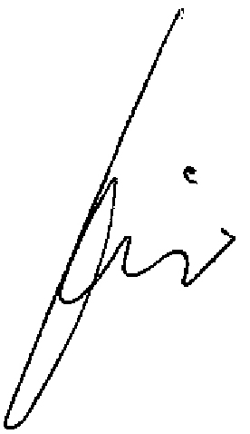

Jacques Elvinger For and on behalf of the Board
Sub-Fund liquidation – option to take action ends 5 October 2015 at 1430 CET
JPMorgan Funds - Corporate Bond Portfolio Fund I  Reason for liquidation The Sub-Fund will reach the end of its Principal Investment Period (“the PIP”) on 30 September 2015. After this date, the Sub-Fund will invest in European short-term debt securities, as stated in the prospectus. Based on the current low interest rate environment, the yield of this Sub-Fund after the PIP, including the deduction of fees, will likely be negative. We don’t believe this outcome is in the best interest of shareholders, and as a result, the Board has decided to liquidate the Sub-Fund. |  | The Liquidation  Liquidation date 5 October 2015  Deadline for receipt of switch/  redemption orders 5 October 2015at  1430 CET  Where unclaimed liquidation proceeds will be deposited Caisse de Consignation, Luxembourg  The Fund  Name JPMorgan Funds  Legal form SICAV  Fund type UCITS  Registered office  6 route de Trèves  L-2633 Senningerberg, Luxembourg  Phone +352 34 10 1  Fax +352 3410 8000  Registration number (RCS Luxembourg)  B 8478  The KIID, prospectus and most recent financial reports are available at  jpmorganassetmanagement.lu or from  the registered office.
Your Options
1 Switch your investment to another sub-fund. We must receive your dealing instructions by the deadline shown in the right-hand column. Be sure to read the Key Investor Information Document (KIID) for any sub-fund you are considering switching into and, for further information, the prospectus.
2 Redeem your investment. We must receive your dealing instructions by the deadline shown in the right-hand column.
3 Take no action and receive liquidation proceeds automatically. Any shares of the Sub-Fund that you still own after the deadline will be liquidated. We will send the proceeds to the address of record on your account soon afterwards.
You may want to review these options with your tax adviser and your
financial adviser. The liquidation could have tax consequences and could affect the composition of your investment portfolio.
Regardless of which option you choose, your Sub-Fund will not charge any redemption fees so long as we receive your dealing instructions before the deadline.
The Sub-Fund will bear securities transaction costs only; all other costs associated with the liquidation will be paid by the management company. To help ensure an orderly and efficient liquidation process, the Sub-Fund may begin liquidating holdings in the period leading up to the liquidation date.

Timeline

5 October 2015, 1430 CET  • Your Sub-Fund stops accepting orders to switch or redeem shares. |  | 5 October 2015, after close  of business  • The liquidation occurs. |  | 8 October 2015  • Proceeds from the liquidation will be distributed.

Please be advised that the latest version of the prospectus and articles of incorporation as well as copies of the latest annual and semi annual report are available free of charge upon request at the registered office of the Fund or from the Fund local representative. The latest version of the Prospectus is also available on the website www.jpmorganassetmanagement.com

